**Problem Statement**

We know that every person is unique so as their concerns/questions/thought on the same subject. Thus, it is necessary to communicate with every person to clear their ideas so that they can make their decision about the subject. Since it is not possible for a subject expert person to communicate with every person regarding their questions/concerns, there is a need of automating the process of communication. For this we will develop the chatbot with specific subject of “After 10th and 12th consultation”. This chatbot will answer the questions or doubts regarding which stream should be chosen, what are the different future career options available, etc.

**Objective**

1. To provide details of different available streams for pursuing.
2. To guide during the process of admission.
3. To guide the user through different career opportunities, present in various stream.
4. To help the user to find the college according to their convenience

**Introduction**

One to One communication is very effective when it comes to solve any doubts, clear any concept or to get information based on which one’s future decisions are depended. This communication can be between any person and the subject expert. But there are only limited number of experts in each domain or subject thus, not every person is able to communicate with the expert. This problem of limited number of expert resources can be tackled by automating the communication of expert using the chatbot. The chatbots are the automated bots that are trained to answer/solve/clear the questions/doubts of the user. The chatbots are of 2 types 1. General purpose chatbots 2. Domain Specific chatbots

The General purpose chatbots are those chatbots that are able to answer basic questions but are not able to answer any domain specific questions. Whereas domain specific chatbots are constrained to only one subject. These bots are able to answer any questions based on that domain but cannot answer a question from another domain.

As we all know taking admissions after 10th and 12th are very complicated and tedious process and students also get confuse on deciding to which stream to select as they are unaware of the different streams offered by the college. Thus, the education consultation chatbot can prove handful to the students since it can help and guide the students to select the stream for further studies, choose the college which can offer the required stream and also will guide the students in the admission procedure.

**Conclusion**

The implementation of “After 10th and 12th consultation” was to provide the students with proper guidance and suggestion to choose their field of career. It also helps and guides the students in the process of admission. We all know that choosing the stream/career option after 10th and 12th is very crucial phase of students and they must be properly guided during this phase but there are very few experts/councillors who can guide the students during this phase thus, this chatbot can be used to guide the students. A chatbot is a topic specific bot trained to answer the queries regarding stream selection, profession selection, gathering knowledge about different career options in the world, searching college offering particular stream/option and searching college according to location.

The chatbot is now currently running in offline mode but in future the chatbot can be made to run in online mode and also the database of various institute can also be connected to the chatbot so that the chatbot can guide the students more effectively and in various aspects. Even the chatbot can be upgraded to voice level so that the interaction with the chatbot can be more efficient and livelier. The important work that can be done in the chatbot is to make it multilingual so that the chatbot can be used by the wider number of student population

**Proposed System**

1. Analysis/framework/Algorithm

We will be using python3.6.x as the language to build the chatbot. The chatbot will be made of two modules. First module is used to train the neural network model with the manually prepared data and save the trained model. This data contains different set of possible questions that the user might ask to chatbot along with the answers to it. The data is in the form of json file. Second module will be an interface to communicate with the user. The interface will contain a textarea to type the query, a button to send the query and a whitespace to show all the queries with its answer. When the user will submit the query, the module will pass the query through trained model to generates its answer. This answer will be displayed on the whitespace as an output.

1. Design details

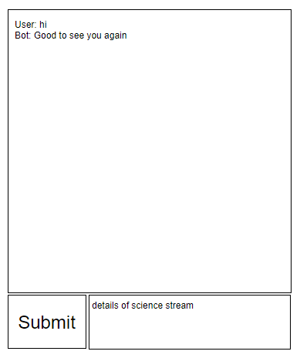

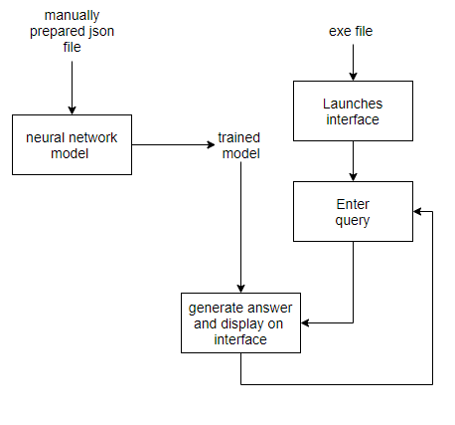

1. Methodology
2. Train and save the neural network model with manually prepared data.
3. Display the interface for user to interact.
4. Accept the query written by the user and pass it to the trained model to generate its answer.
5. Display the generated answer on the interface and wait to accept another query.

Modules and Description:

Module1:- Training a Chatbot

In this module the chatbot will be trained to recognize the pattern of questions given as an input by the user. To train the model we need to first create a data file which is names as “intent. json”. This file includes data in key value pair format with keys as tags, patterns or questions and responses associated to the respective pattern.

Once data is loaded each and every pattern for each intent in the file will be tokenize and will be appended to ‘words’ list. After that each and every word in the ‘words’ list will be lematize to obtain the root form of the word. In order to maintain program state 2 pickle files will be created for words and classes (contains tags)

The next step is to create a training data to feed as an input to the model. The training data is an 2d list with one argument is bag and output_row. The bag is binary list in which if word is present it is marked as 1 else 0. The output row contains index of the tags key in the ‘classes’ list.

The last step is creating input nodes and output nodes for the model which are bag and output_row respectively after converting into and numpy array.

The model used is a sequential model which is simplest model with the help of keras library. The model contains 2 layers and an output layer with dropout factor of 0.5 to avoid overfitting and activation function such as relu and softmax.Thus with the above parameters the model will be trained.

Module 2: Creating a tkinter GUI

In this module we created an GUI a chat bot GUI so that the user can interact with to clear their doubts or have one to one session. The GUI comprises of a Message EntryBox, ChatLog and a send button. The process from user putting up a question to getting a response in carried out through four different function which are described ahead:

1. Function send:

After clicking the send button, the message present in the entry box will be pass to the function to get the response from bot. The response that will get will be placed in the chatlog to display it to user. The Function also calculates the percentage of visitors that are satisfied with the chatbot

1. Function chatbot_response

The message argument passed from send function will be passed to two other function in order to predict the class and with that class get the response.

1. Function bow This function will first clean uo with the help of tokenizer and then create a list of 1’s and 0’s based on the matching of word.
2. Function predict_class This will take output from the bow function and will predict the result from the model generated during training module. The function returns a 2d list ‘results’
3. Function getResponse

The final function which will provide the response. It will take output from the predict class specifically the tag. It will first match the tag with the list of intent present in the file and once matched it will randomly choose a value from the response key of the respective tag. It will send the result back so that the result can be displayed on the screen.